DATA ENGINEERING-2 REPORT: YOUTUBE COMMENT SENTEMENT ANALYSIS WITH GCP
Group Names: Rohan Mahaveer, Manoj Saligrama Harisha, Namratha Prakash, Valeska Joshna Dsouza
Course: MSc in Data Science and Analytics
- Introduction
Real-Time YouTube Sentiment Analysis Pipeline
Unlocking Audience Insights at Scale
Why This Matters:
YouTube generates millions of comments daily—raw, unstructured feedback representing real audience emotions and reactions.
Content creators and brands need to understand:
- What viewers love or hate about videos
- When sentiment shifts occur (viral spikes, controversies)
- How to respond proactively to build engagement and loyalty
This Pipeline Delivers:
Automated, serverless GCP architecture that transforms chaotic comment streams into actionable sentiment metrics—hourly, at scale, without ops overhead.
From Raw Comments → Strategic Insights in minutes, not weeks.

- Problem Statement
Monitoring YouTube Sentiment at Scale
The Challenge:
- Thousands of YouTube comments arrive hourly across channels
- Manual sentiment analysis is unscalable and time-delayed
- Content creators need real-time audience reaction insights
- Traditional approaches require expensive servers and DevOps overhead The Challenge.
- High-volume YouTube channels receive thousands of comments hourly
- Manual sentiment analysis is unscalable and time-consuming
- Need to understand audience sentiment trends in near real-time
- Cannot respond quickly to negative sentiment spikes.

- Architecture OverView
P1: Training Pipeline (Batch)
P2: Prediction Pipeline (Streaming) Orchestration: Airflow hourly schedule Core Pattern: Pub/Sub → Dataflow → BigQuery ML → Sentiment Table
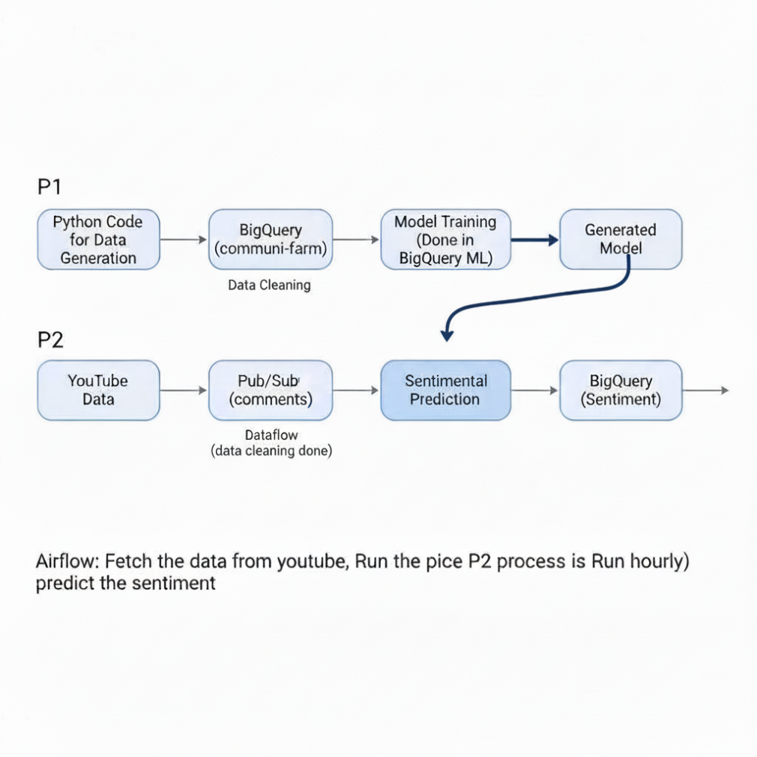
- TWO PHASE ARCHITECTURE
Phase 1: Model Training Pipeline - Build & train the sentiment model once
Step 1: Python generates labeled training data
Step 2: BigQuery SQL cleans & preprocesses data.
Step 3: BigQuery ML trains sentiment model (SQL).
Output: Reusable ML model ready for predictions.

Phase 2: Real-Time Prediction Flow - Apply model to new comments hourly
YouTube API: Fetch new comments hourly
Pub/Sub: Stream comments as messages
Dataflow: Clean & transform text (Apache Beam)
BigQuery ML: Apply model, store results with sentiment labels.

- YouTube Data API Concepts
- commentThreads.list() - Fetch top-level comments
- Pagination with nextPageToken
- Rate limits: 10,000 units/day (100 comments = 1 unit).
- Authentication: API key or OAuth 2.0.

- Pub/Sub Messaging
Topic: youtube-comments (publish JSON payloads) Subscription: comments-sub (Dataflow subscriber) Message format: {"video_id": "...", "text": "...", "timestamp": "..."} At-least-once delivery guarantees.
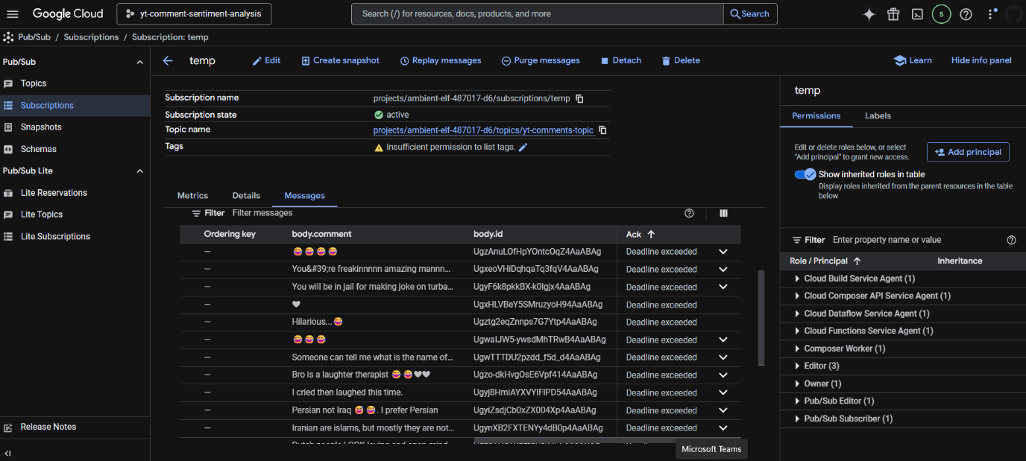
- Dataflow (Apache Beam)
- Runner: DataflowRunner (managed).
- Transforms: ParDo for cleaning, ML.PREDICT calls.
- Windowing: Fixed windows for hourly batches.
- Auto-scaling: 1-100 workers based on load.
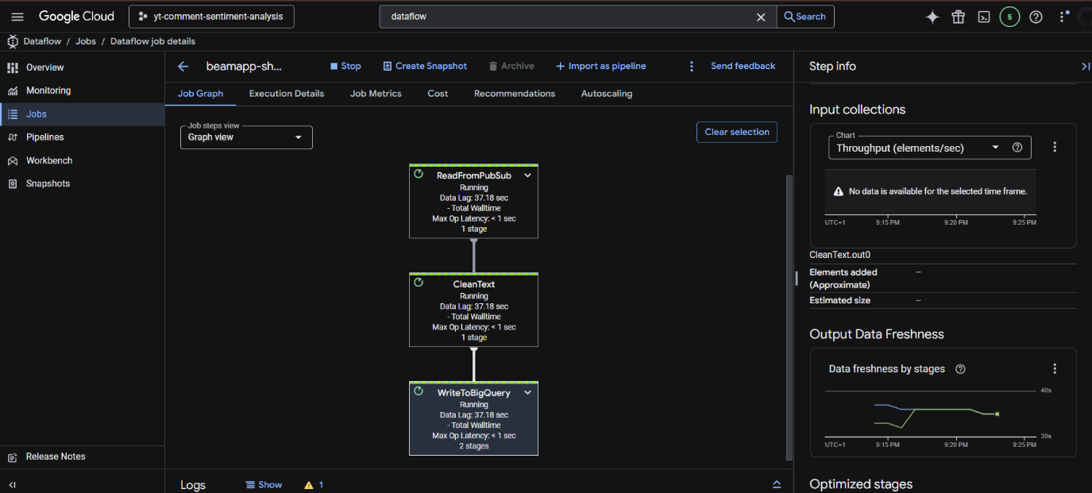
- BigQuery ML Model Lifecycle
CREATE MODEL → ML.TRAINING_INFO → ML.PREDICT → ML.EVALUATE
Model type: logistic_reg (binary classification)
Features: TF-IDF vectors from text
Hyperparams: max_iterations=20, L2_reg=0.1
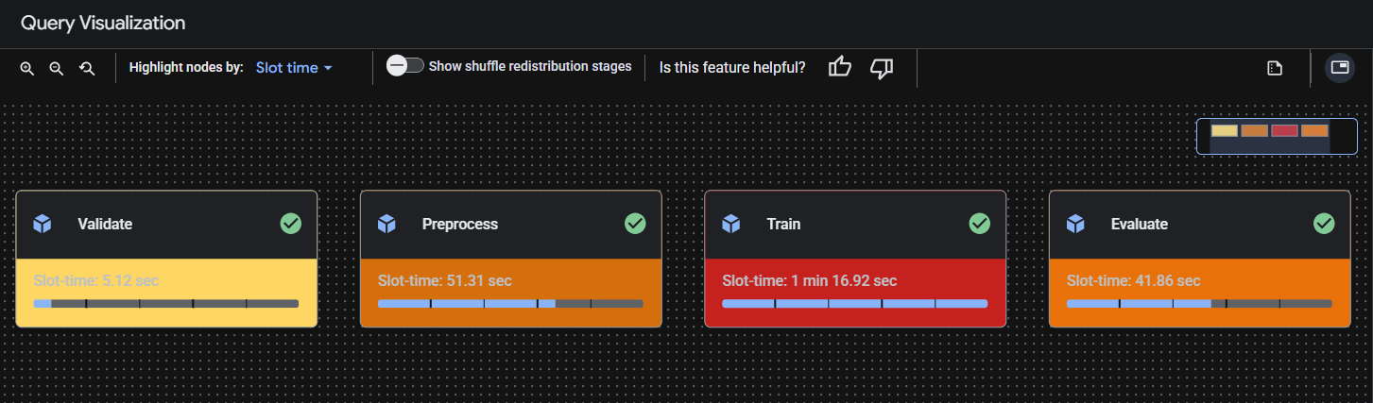
- Airflow DAG Patterns
Operators:
- CloudFunctionOperator (fetch comments)
- DataflowTemplatedJobStartOperator (prediction)
- BigQueryOperator (model refresh)
Schedule: @hourlyDependencies: fetch >> predict >> validate.
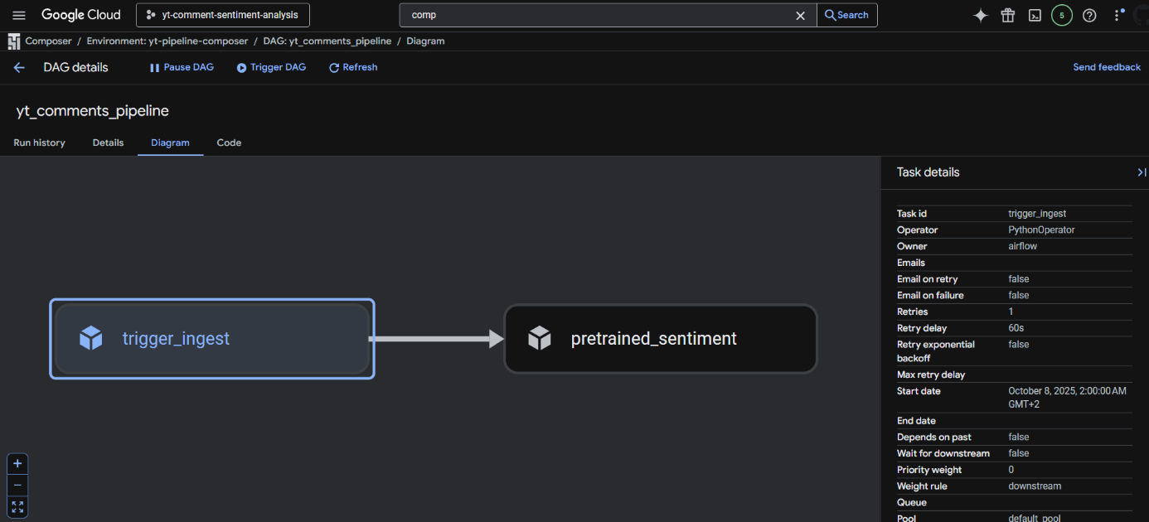

- Data Cleaning Pipeline
Steps:
1. Lowercase + trim
2. Remove URLs (REGEXP 'http')
3. Remove @mentions, #hashtags
4. Min length 10 chars
5. Remove duplicates (ROW_NUMBER)

- Error Handling
- Dataflow dead-letter queue
- Airflow retries (3x)
- BigQuery query validation
- Pub/Sub message ACK timeouts.

- CI/CD Pipeline
1. GitHub Actions
2. Terraform for infra
3. Cloud Build for Dataflow templates
4. Cloud Composer environments.
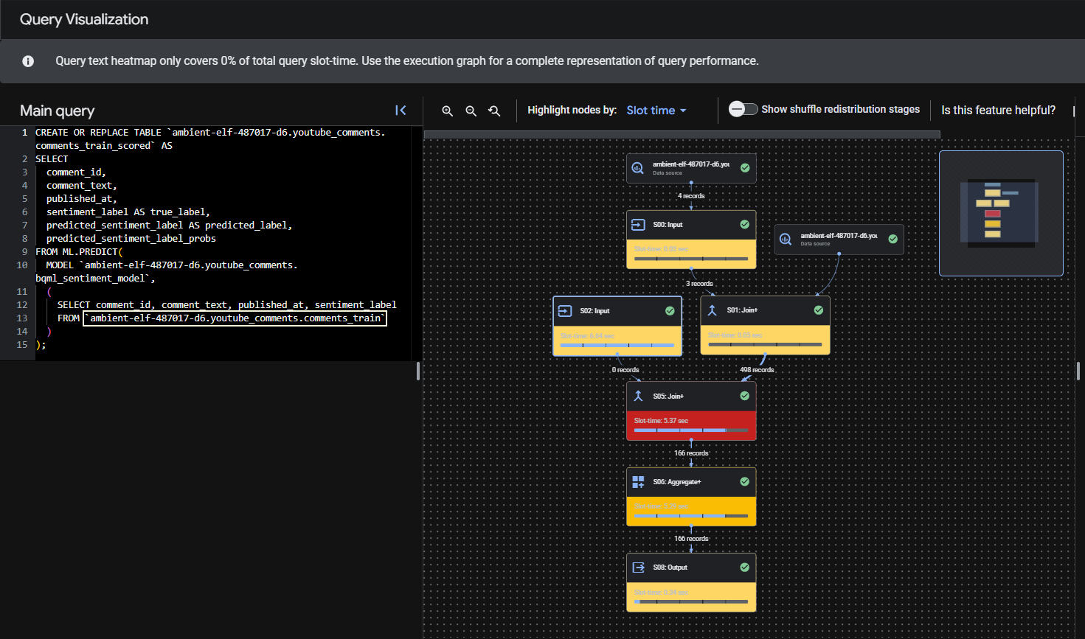
- Outputs
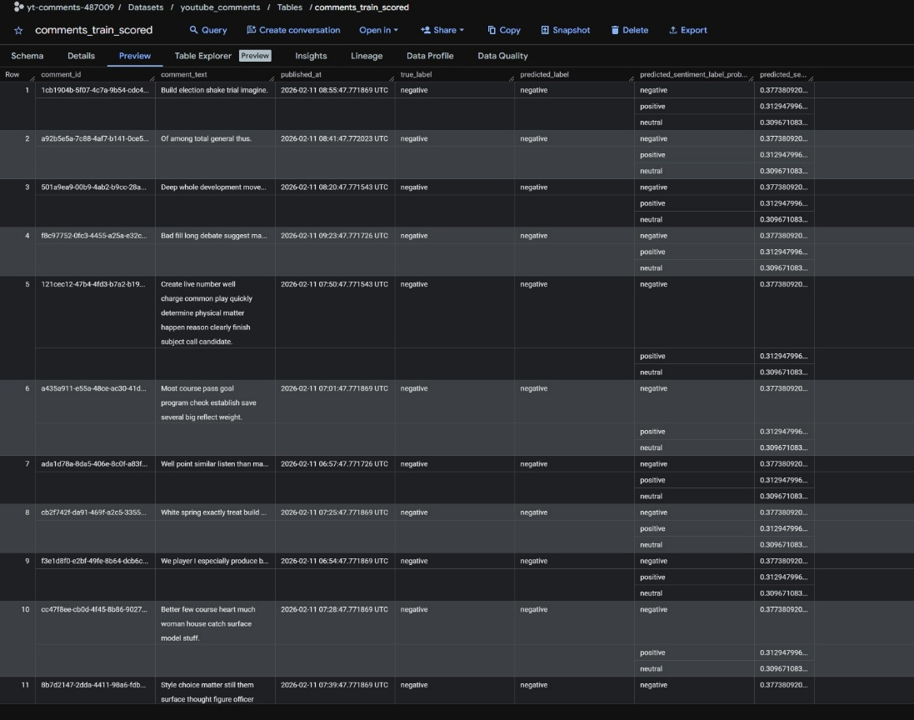
- Model Performance
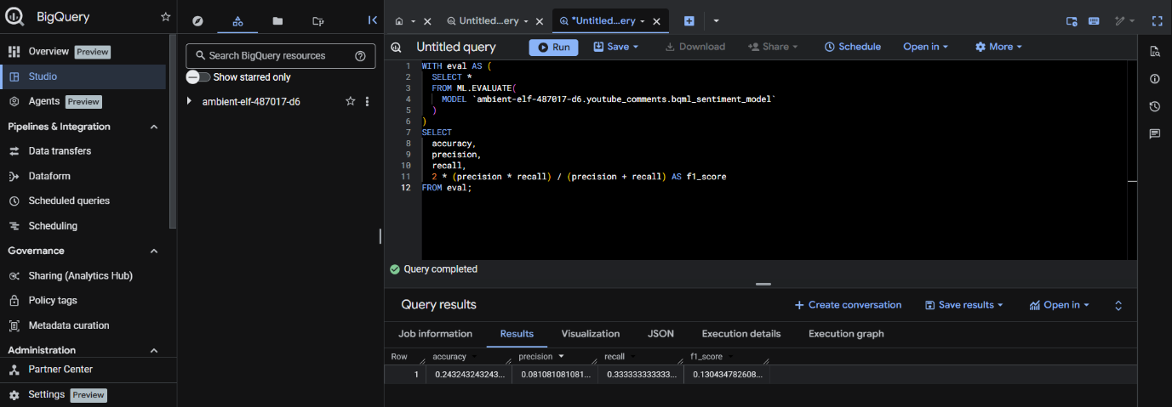
- Future Enhancements
- Vertex AI (Gemini 1.5) integration
- Multi-language support
- Video title/description analysis
- Competitor channel benchmarking

